Top fashion brands and racism:

Humans are believed to be God’s creations and they come in every color, height, and religion. However, despite everyone trying to promote equality and freedom across the globe, there is various difference faced by millions in one way or the other.

Are there any favors or priority basis require based on the color or complexion of the people? What is the difference between people with different complexions and body textures? Is fairness a definition of beauty?

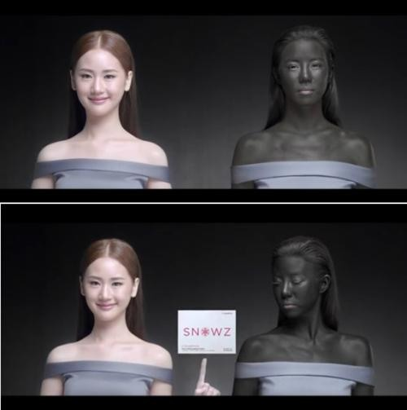

Several questions aroused with the recent act of racism with the death of George Floyd. The ‘Black lives matters’ campaign and protest activities started flourishing worldwide.

How much diversity does a ramp show? How many brands promote many complexions for marketing and product advertisements?

 Many famous brands of clothing and beauty products have also shown their concerns about the issue of racism. When the brands like Fenty Beauty of Rihanna have marked their territories by coming up with the products for every complexion and texture, many like Tarte have only focused the production for white people. Tarte has most of its products for white complexion and their shades and nothing seems to be there to fit the darker ones. Tarte’s new line of cosmetics lacks the products for dark-skinned people! Apart from Fenty Beauty, Maybelline and Make Up For Ever have also been including various shades and colors in their cosmetics.

Why are there these promotions done by white beauties? Do clothing and makeup only show their efficiency in white tones?

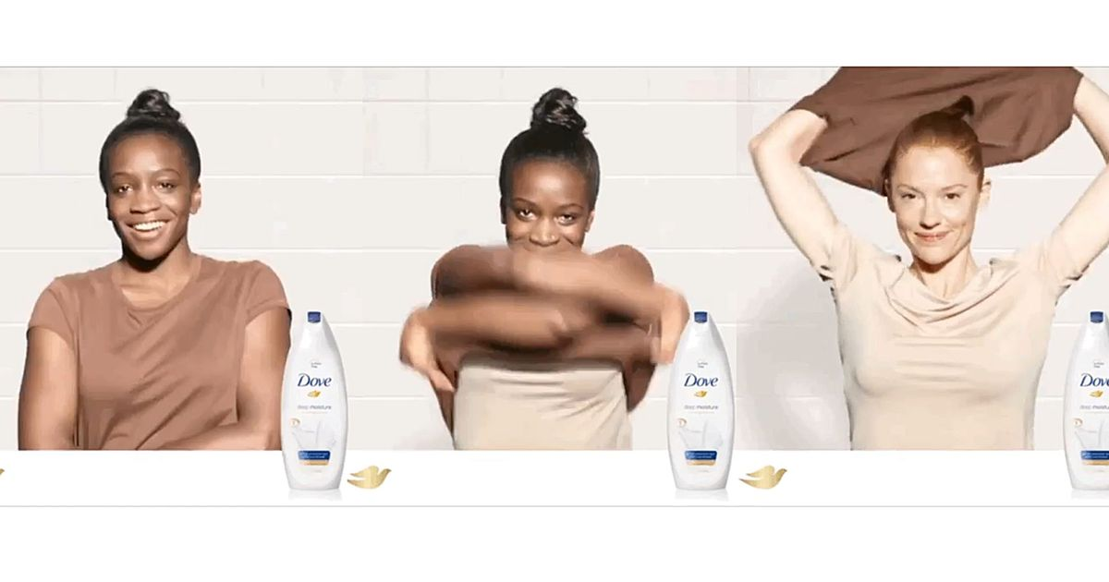

These practices of racism are no more hidden, and most of the public is noticing it and questioning about the same. Also, several top makeup artists and experts like James Charles and Laura Lee posted on twitter how disappointing it is to see the lack of diversity in the products of Tarte! People also tweeted how in the name of Shape Tape, Tarte should not have come up with 50 shades of eggshells followed by 2 dark caramel shades in their foundation range that is released recently.

Records reveal that most of the top fashion brands lack diversity among their staff and tries hiring the fair and white women as models to promote their products.

Recently, Gucci came up with a high collar sweater that was considered as the blackface and was criticized too that made them remove the product from their list. H&M too pulled out an ad where they featured a black boy running around with a sweatshirt stating ‘the coolest monkey in the jungle’.

Experts think that the retailers stay in the global villages and despite every movement for diversity and anti-racism, no one seems to indulge more in promoting it!

With several of these issues rising about racism, H&M, Prada, Gucci, all of these top brands have hired diversity experts to maintain the ratio of their staff and clients and promote diversity in talented people.

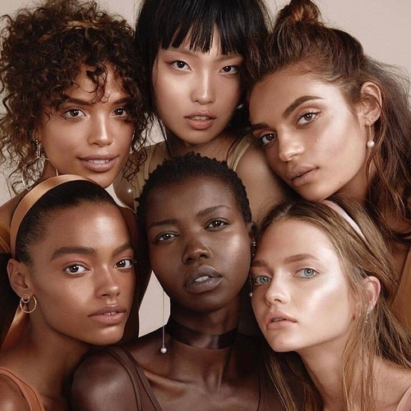

Also, various top brands have been coming up with the measures in support of ‘Black lives matter’ campaign, like:

* Glossier made a donation of$1 million to the black people owned brands and beauty products.
* Fenty Beauty posted the no business for Tuesdays as #BlackoutTuesday, with this they aim to promote the campaign.
* Anastasia Beverly Hills pledged $1 million for the fight against racism.
* Huda beauty too made a donation of $500,000 to the National Association for Advancement of Colored People.
* Beautyblender donated a day’s profit all for the Equal Justice initiatives.

Similarly, many of such top fashion and cosmetic brands have supported the campaign with various measures.

However, to wipe away the racism completely, and for brands to maintain diversity, there is a lot more awareness and checks to be maintained. People are needed to promote equality and diversity in their workspaces!